User manual

* Library import.

* Open the file in read mode and in case of failure display that there is an error.

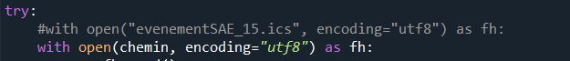

* Organize the file with line breaks.



* Create an array.



* Declare a variable for easier reading of the file.

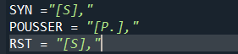

* For events in the file, if the event starts with 11:42, select the line so all our operations will be done on it.



* If it is written flag in position 5 the name of the event will have for a name "time" and will be followed by the text that is in the position 0 and so on.



* Open the file in write mode and so we will emit the 3 events successively followed by a line break.
* 
* I close the file

